Resolution sensitivity of tropical turbulent fluxes and precipitation in NorESM models

**Abstract**

Abstract

We evaluated the ¼° model NorESM1.3 in which the well-known “double-ITCZ problem” in the Pacific is mitigated. However, excessive precipitation is produced in the northern branch of the ITCZ. The excessive precipitation is consistent with overevaluated latent heat flux in the tropical ocean. Further analysis shows that in NorESM1.3, the latent heat flux is too sensitive to the surface wind. The increased sensitivity in the ¼° model is partly contributed by small-scale air-sea interaction. The sensitivity of latent heat flux to surface wind, with the scale finer than 2.5°, is up to 40 (Wm-2 / ms-1), which is almost twice of that with scale coarser than 2.5°. This study helps to understand extra air-sea interaction resolved by higher-resolution models, and helps to tune and correct the related model bias.

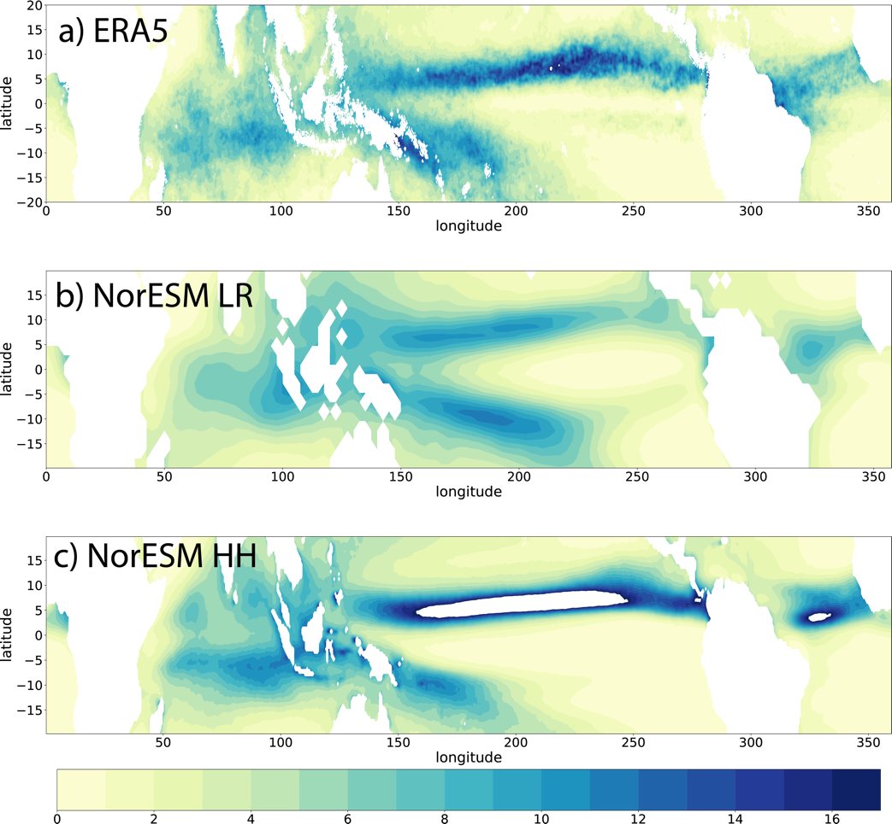

Fig. 1 Mean precipitation (unit: mm/day) in (a) ERA5, (b) NorESM_LR and (c) NorESM_HR.

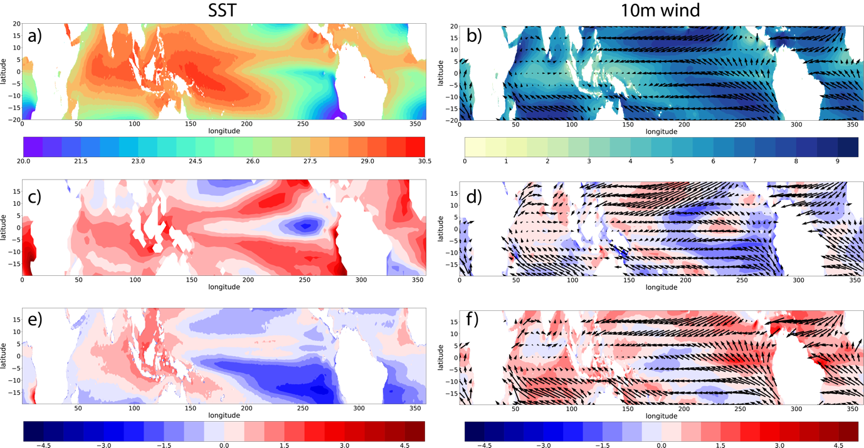

Fig.2 (a) Mean SST (°C) in ERA5, (b) 10m wind in ERA5, shade is wind speed (m/s), vectors indicate the 10m wind direction. (c) and (d) Bias of SST and 10m wind in NorESM_LR related to ERA5. (e) and (f) Similar as (c) and (d) but for NorESM_HR.

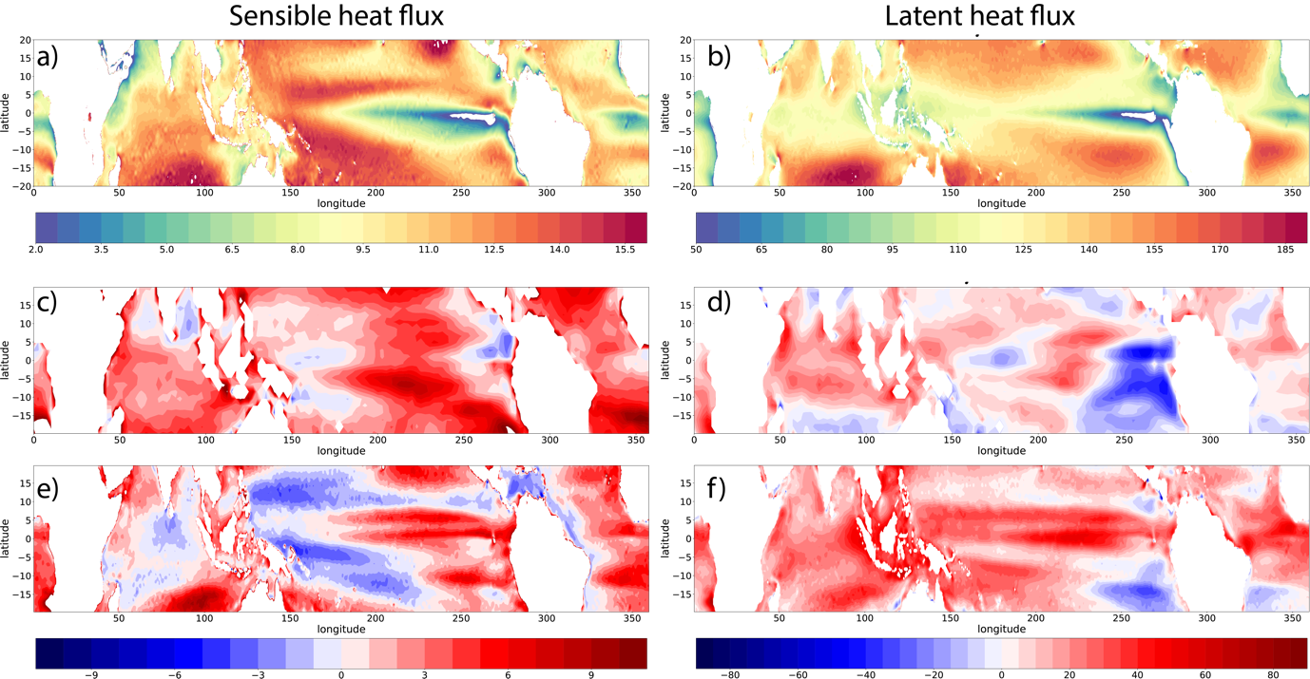

Fig.3 (a) Mean Sensible heat flux (W/m2) in ERA5. (b) Mean latent heat flux (W/m2) in ERA5. (c) and (d) Bias of sensible and latent heat flux in NorESM_LR. (e) and (f) Bias of Sensible and latent heat flux in NorESM_SR

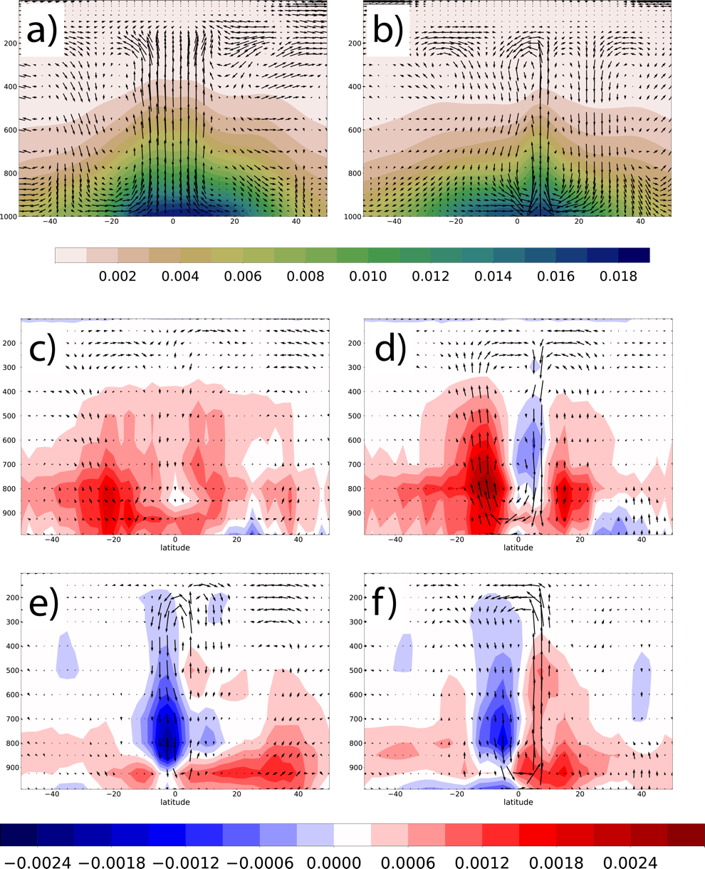

Fig. 4 (a) Hadley circulation (vector) and specific humidity (shade, in kg/kg) in western pacific inERA5. (b) Hadley circulation and specific humidity in eastern pacific in ERA5. (c) Biases of Hadley circulation and specific humidity in western pacific in NorESM_LR. (d) Biases of Hadley circulation and specific humidity in eastern pacific in NorESM_LR . e)-f) Same as c)-d) but for model NorESM_SR

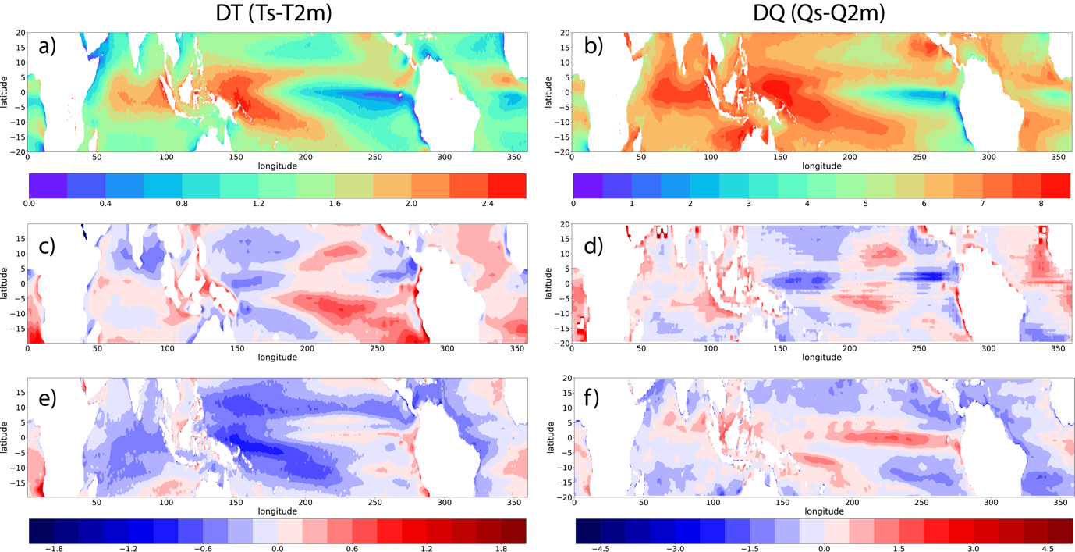

Fig.5 (a) Mean state of temperature difference between SST and 2m air temperature (DT=SST-T2m, in °C) in ERA5. (b) Mean state of specific humidity between sea surface and 2m atmosphere (DQ=Qs-Q2m, in g/kg) in ERA5. (c) and (d) Bias of DT and DQ in NorESM_LR. (e) and (f) Bias of DT and DQ in NorESM_HR.

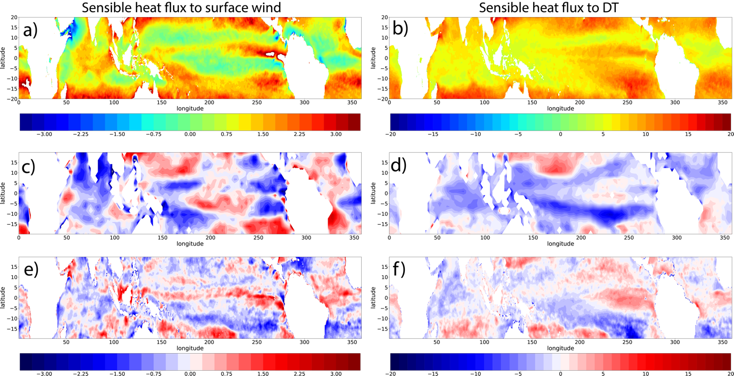

Fig.6 (a) Regression coefficient of sensible heat flux to 10m wind in ERA5. (b) Regression coefficient of sensible heat flux to DT in ERA5. (c) Bias of regression coefficient of sensible heat flux to 10m wind in NorESM_LR. (d) bias of regression coefficient of sensible heat flux to DT in NorESM_LR. (e) and (f) Similar as (c) and (d) but for NorESM_SR.

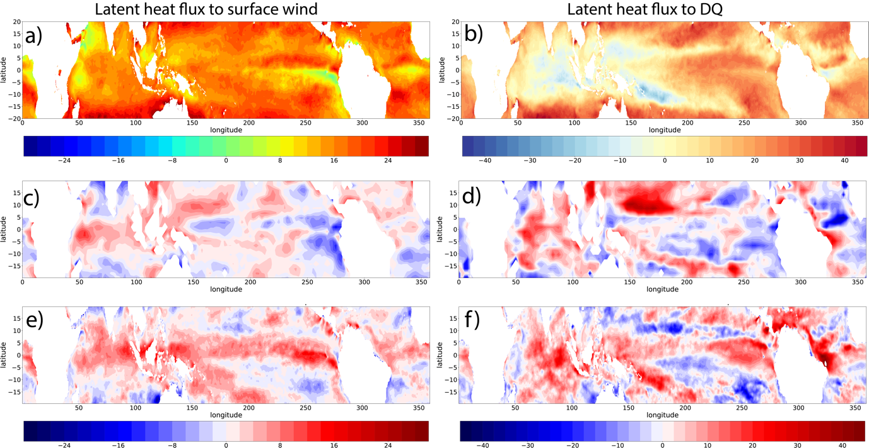

Fig.7 (a) Regression coefficient of latent heat flux to 10m wind in ERA5. (b) Regression coefficient of latent heat flux to DQ in ERA5. (c) Bias of regression coefficient of latent heat flux to 10m wind in NorESM_LR. (d) bias of regression coefficient of latent heat flux to DQ in NorESM_LR. (e) and (f) Similar as (c) and (d) but for NorESM_HR.

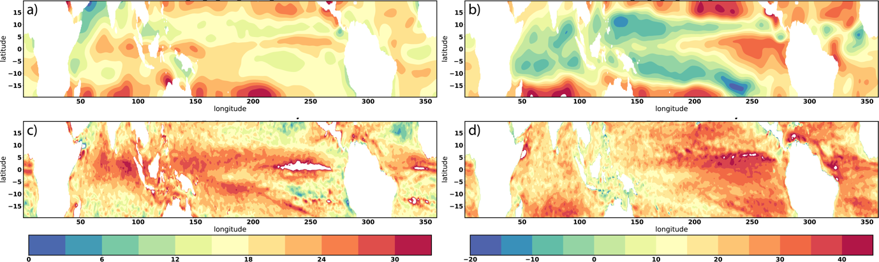

Fig.8 Regression coefficient of latent heat flux to 10m wind speed (a, c) and latent heat flux to DQ (b, d) in NorESM_HR. (a) Large-scale latent heat flux to large-scale 10m wind. (b) Large-scale latent heat flux to large-scale DQ . (c) Small-scale latent heat flux to small-scale 10m wind speed. (d) Small-scale latent heat flux to small-scale DQ. Large-scale latent heat flux, 10m wind speed and DQ are low-pass filtered to remove variability with scales smaller than 250km. Small-scale latent heat flux, 10m wind speed and DQ have variability with scales smaller than 250km.

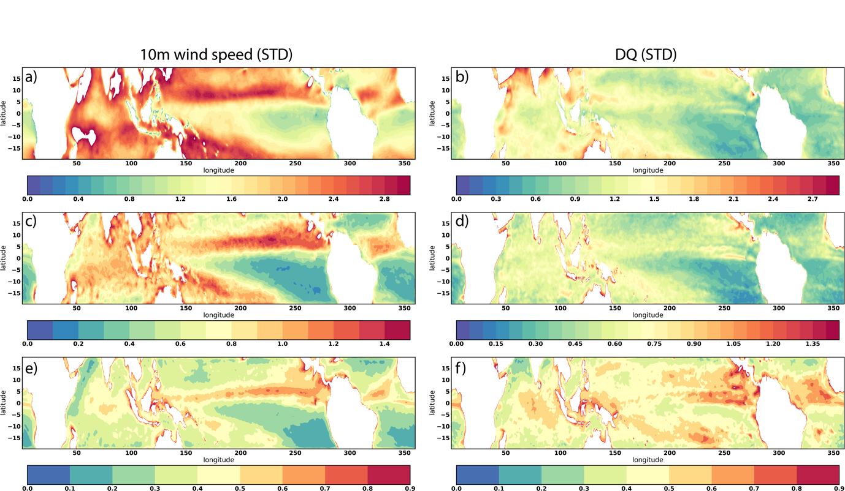

Fig.9 Standard deviation of 10m wind speed and DQ in NorESM_HR. (a) and (b) Original fields. (c) and (d) Small-scale fields. (e) and (f) Ratio of standard deviation in small-scale field to original field

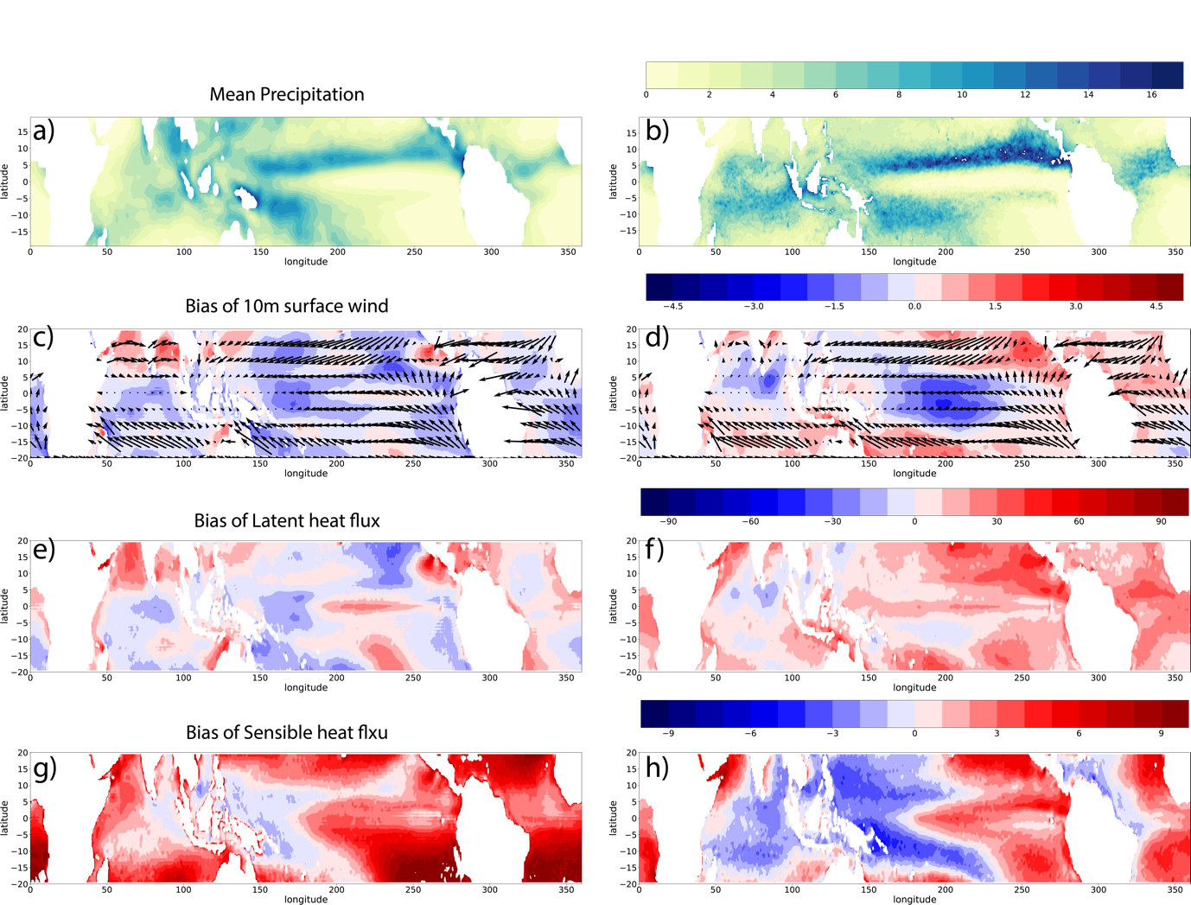

Fig.10 (a) Mean precipitation (in mm/day) in CAM_LR. (b) Mean precipitation (in mm/day) in CAM_HR. (c) and (d) Bias of 10m surface wind (vector) and 10m wind speed (shaded, in m/s) in CAM_LR and CAM_HR. (e) and (f) Bias of mean latent heat flux (in W/m2) in CAM_HR and CAM_LR. (g) and (h) Bias of mean sensible heat flux (in W/m2) in CAM_HR and CAM_LR.

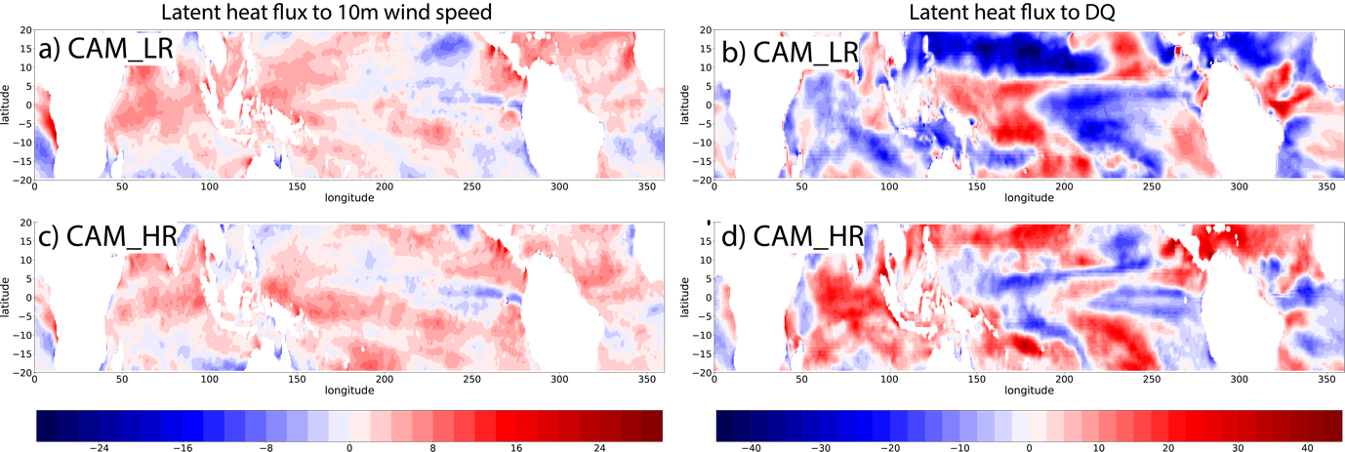

Fig. 11 (a, c) Regression coefficient of latent heat flux to 10m wind speed. (b, d) Regression coefficient of latent heat flux to DQ. (a, b) are for CAM_LR and (c, d) are for CAM_HR